Nama : Rizky Mahesa Ramadhan

NIM : 1207070112

Mata Kuliah : Praktikum Pengolahan Citra Digital – TKK

PRAKTIKUM 7

1. **Praktikum 7.1 - Contrast Enhancment**

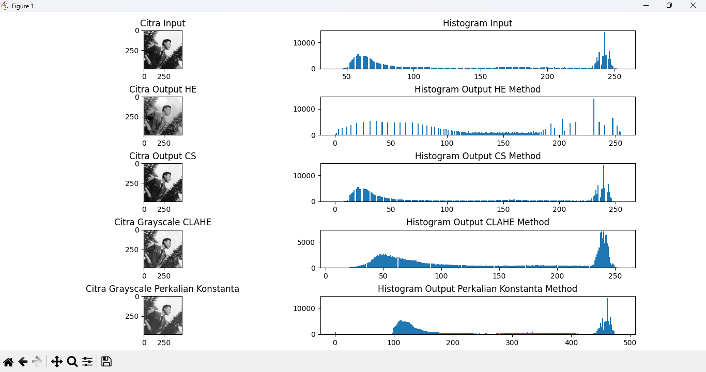

1. **Praktikum 7.2 - Gray Level Slicing**

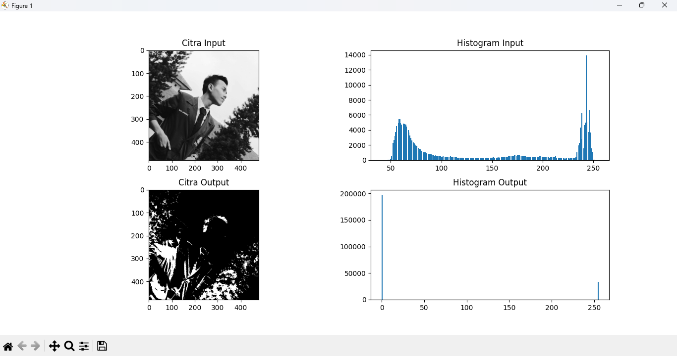

1. **Praktikum 7.3 - Filter Rerata**

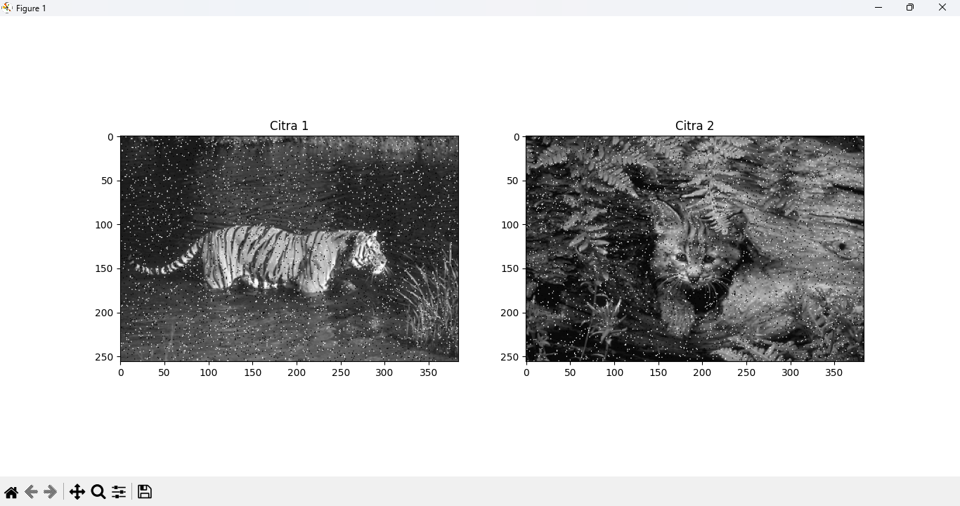

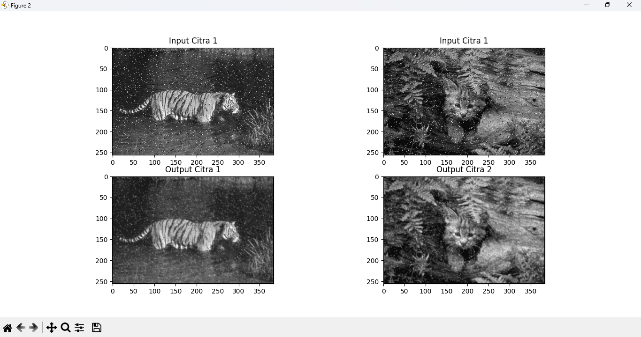

1. **Praktikum 7.4 - Filter Median**



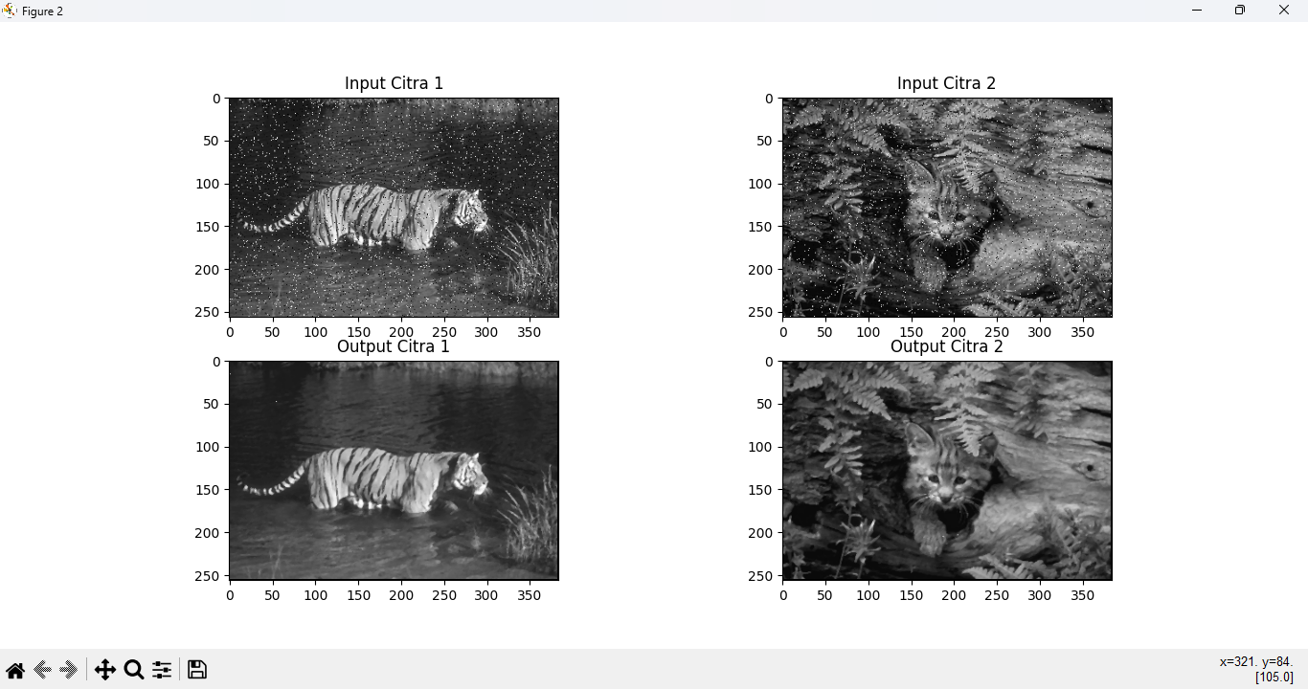

1. **Praktikum 7.5 - Filter Batas**



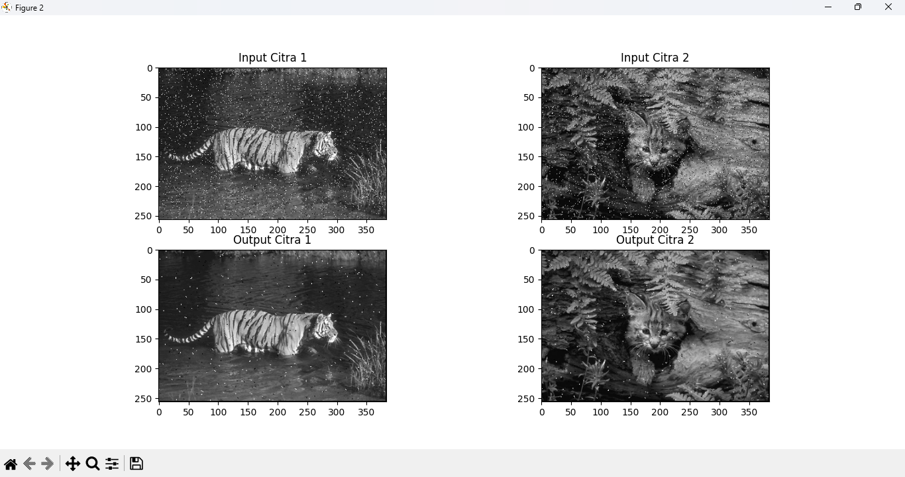

1. **Praktikum 7.6 - Konvolusis**

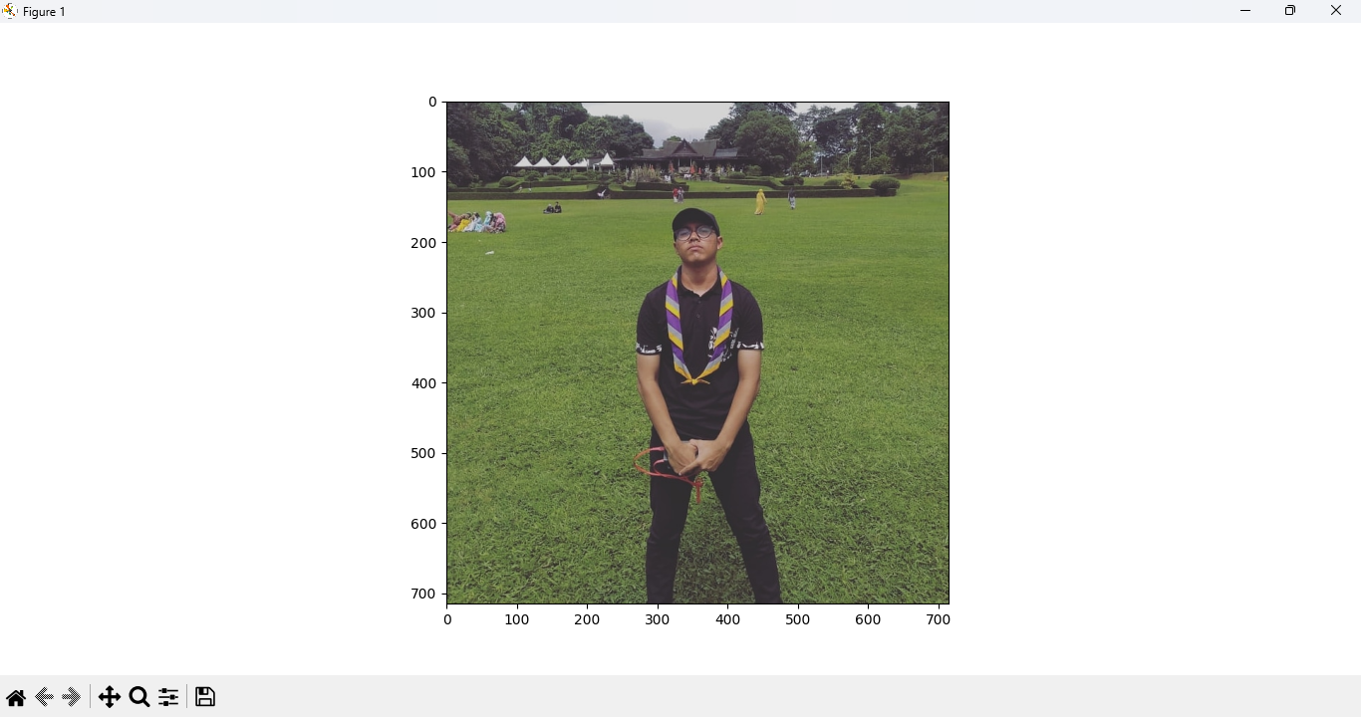

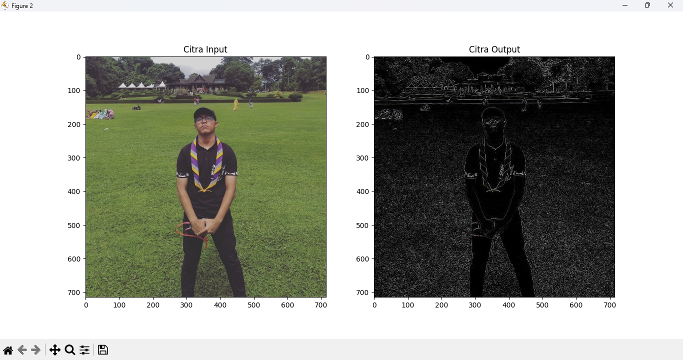

1. **Praktikum 7.7 - Operasi Image Filtering dan Thresholding**

